**Assessment Cover Page**

|  |  |
| --- | --- |
| *Student Full Name* | Alexandra Munik Silva |
| *Student Number* | 2024268 |
| *Module Title* | Data Analytics for Business |
| *Assessment Title* | How Important Is Data Analytics for Business Strategy |
| *Assessment Due Date* | Sunday, 27th October 2024 |
| *Date of Submission* | Thursday, 26th October 2024 |

**Declaration**

By submitting this assessment, I confirm that I have read the CCT policy on academic misconduct and understand the implications of submitting work that is not my own or does not appropriately reference material taken from a third party or other source.

I declare it to be my own work and that all material from third parties has been appropriately referenced.

I further confirm that this work has not previously been submitted for assessment by myself or someone else in CCT College Dublin or any other higher education institution.

Contents

Introduction 2

Objectives 3

Data Source 4

Scope 4

Data Collection 4

Problem and Solution 4

Research 4

Action Plan 4

Data Monitoring 4

Boundaries 4

Timeline 5

Ethical Considerations 5

References 6

# Introduction

Nowadays most big companies have been using data to guide at every step of decision making, Croll (2013) mentions how important is to know about metrics since this metrics can impact directly on the results of this company. In another words, every step is necessary collect data to make sure about strategy and future decisions.

According to Data camp (“What is Data Analysis?,” n.d.) data can be used for many sections of a business, data is an important tool to handle with business and strategy, helps the company to take next steps based on facts and not just intuition, for example through data analysis a company is able to know how a particular product or service is performing and thus know how to adjust strategies to improve product development, create insights, improve marketing campaigns, among other possibilities.(“What is Data Analysis?,” n.d.)

According to the data presented below. It is correct to say for example, Ireland in 2021 presented the number of 19% of companies in Ireland using systems to collect data from they customers for marketing purposes. (CRM - Customer Relationship Management)

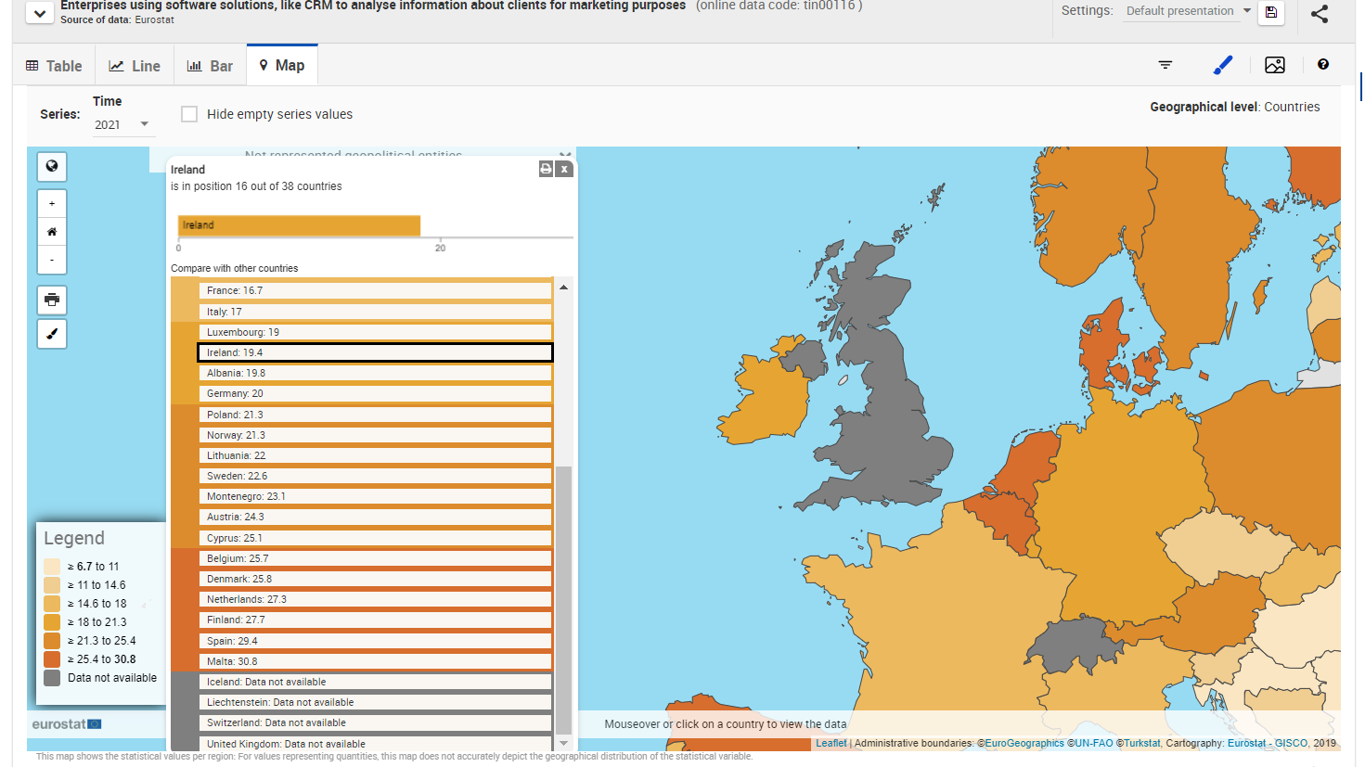

*Figure 1: Enterprises Using Software Solutions for Marketing Purpose 2021 Source: (“Statistics | Eurostat,” n.d.)*

Although another important fact is that in 2015 the number of companies that used data for marketing strategies was 27%, that is 8% more than the percentage presented in 2021. Obtaining data is fuel for data analysis and decision making, however due to privacy regulations the efficiency in data collection has decreased, causing professionals to have to resort to other tools that will be presented below.

*Figure 2: Enterprises Using Software Solutions for Marketing Purpose 2015-2021 Source: (“Statistics | Eurostat,” n.d.)*

This fact has occurred due to the increase in privacy regulations that prevent the capture of data through cookies, for example, due to this it is also necessary to implement new capture methods like Customer Data Platforms (CDPs), for example. ( Statista Research Department, 2024)

An example of this, second (“The New Rules of Data Privacy,” n.d.) was Apple’s upgrade that allows users to block data sharing for many applications, with this many companies lost relevant information about users. As mentioned, this cost more than 10 billion for social media for example that used personal data to share with large companies. (“The New Rules of Data Privacy,” n.d.)

# Objectives

The main objective of this project is to demonstrate the importance and efficiency of data analysis for a company also how using these tools can increase a company's capacity in the short and long term.

“The more customers you have, the more data you can gather, and that data, when analysed with machine-learning tools, allows you to offer a better product that attracts more customers.” (“When Data Creates Competitive Advantage,” n.d.)

Furthermore, this project going to present how data privacy has impacted the industry and how the changes have been beneficial.

Privacy regulation had a major impact on the data industry however, these restrictions opened the possibility for new businesses, allowing new companies to be able to deliver this information in a clear, simplified and secure way to a company and from the target that is being collected this data (customers) in this project, some alternatives and new entrants to the Data Analysis market will be presented.

# Data Source

The data sources where the necessary information will be collected will be mainly through public sources such as Ireland's Open Data, websites like Statista, Eurostat and books that support the principal idea also, field research with small businesses in order to improve the number of businesses using Data Analysis as a competitive advantage.

# Scope

This Project will be divided into two phases, and in the first phase facts will be presented on how companies can be benefit from the implementation of data analysis, presenting real numbers of how the market is in relation to the citation of this tool. Also, what are the challenges in this area and what are the current sources of data collection.

### Data Collection

Collection of data and information that proves that the adhesion to this tool results in benefits for the company.

### Problem and Solution

Exploration of the problem at hand, how the privacy policy has interfered in the data market and what are the current solutions so that data continues to be collected ethically and securely.

### Research

Research data analysis solutions offered by the current market with a focus on small businesses, conduct field research with the intention of understanding the number of small businesses that have joined the analysis tool from the beginning or that have not yet joined, understand reasons for not adhering to it.

### Action Plan

Research and offer solutions for small businesses with the intention of educating and expanding the Data Analytics market.

### Data Monitoring

Data monitoring, checking the number of companies that have adopted data analysis tools in the year 2024 and how these companies are growing in relation to capital and expansion.

### Boundaries

Information on the performance of specific companies will not be included, as well as field research will be carried out only with small companies that have been in the market for less than 5 years so that the behaviour of this group of companies in this period can be understood.

### Timeline

*Figure 2: Project Timeline (High level)*

# Ethical Considerations

The data presented in this project will be collected from public sources with information authorized by the companies that will be mentioned here. Much of the data will be processed in groups of data ensuring that no company name is cited. Any data collected from specific companies in the field survey will be presented anonymously.

# 

# References

Croll, A., Yoskovitz, B., 2013b. Lean Analytics: Use Data to Build a Better Startup Faster. O’Reilly Media, Inc.

Statistics | Eurostat [WWW Document], n.d. URL https://ec.europa.eu/eurostat/databrowser/view/tin00116/default/line?lang=en (accessed 10.23.24).

The New Rules of Data Privacy [WWW Document], n.d. URL https://hbr.org/2022/02/the-new-rules-of-data-privacy (accessed 10.23.24).

What is Data Analysis? An Expert Guide With Examples [WWW Document], n.d. URL https://www.datacamp.com/blog/what-is-data-analysis-expert-guide?form=MG0AV3 (accessed 10.22.24).

When Data Creates Competitive Advantage [WWW Document], n.d. URL https://hbr.org/2020/01/when-data-creates-competitive-advantage?form=MG0AV3 (accessed 10.22.24).